**6.AWS-NATGateway & Elastic IP**

**NATGateway**

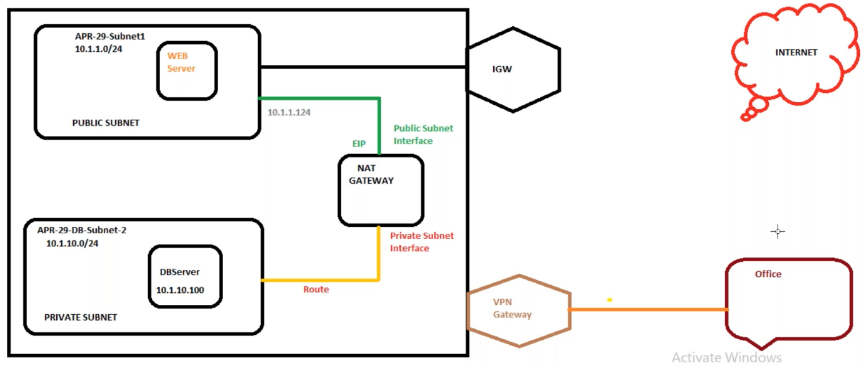

NatGateway won’t allow the request from the internet, but it allow’s the request from the private data base to internet and allow the same request from internet to data base.

We can’t connect the private data base from out side unless you will put gate way called VPN gate way.

The NAT instance is managed by AWS and NATGATEWAY is managed by you.

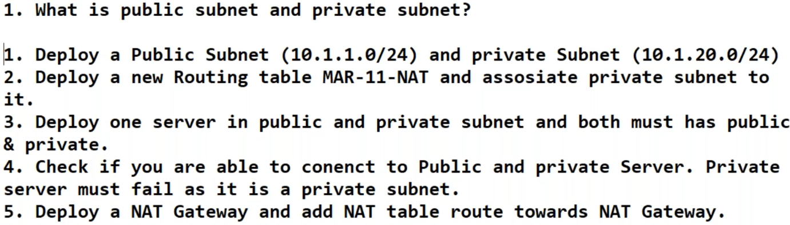

--- don’t allow auto assign ip address for private subnet

--- **QUES why we need public IP…?**

The public IP is used to connect a server over the internet.

--- **QUES the server didn’t have the public IP address what will be the impact…?**

The impact is zero because you can connect the server using VPN

--- **QUES the private IP is compulsory…?**

Yes, if we need 2 servers to communicate with each other, internally the private IP’s are compulsory.

**NATGATEWAY Creating**

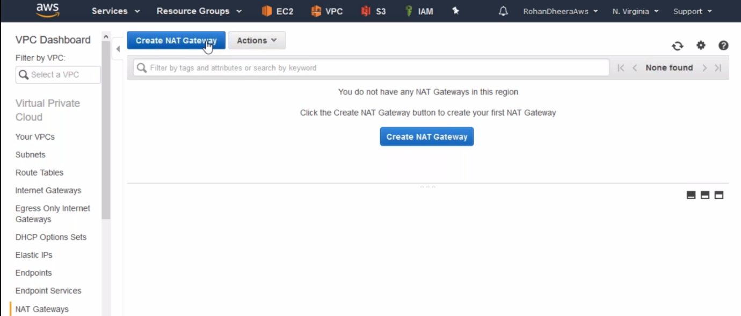

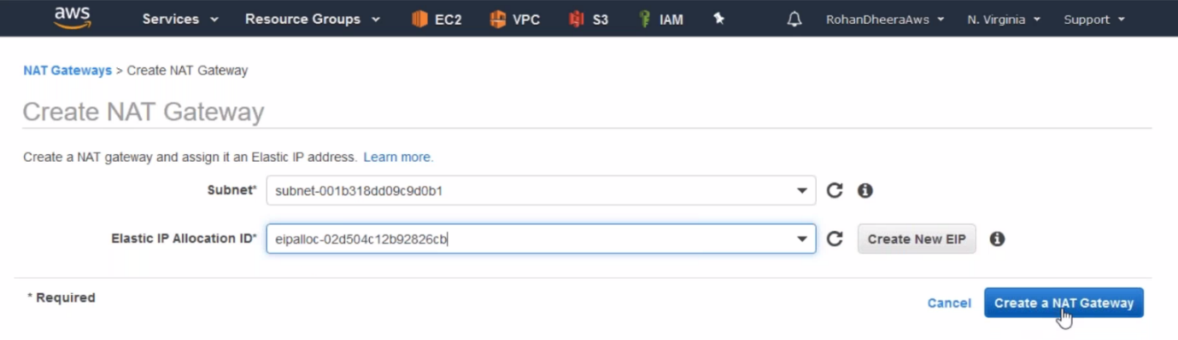

**---** connect this NAT Gateway to the public subnet and use already created Elastic IP address or create a new one here.

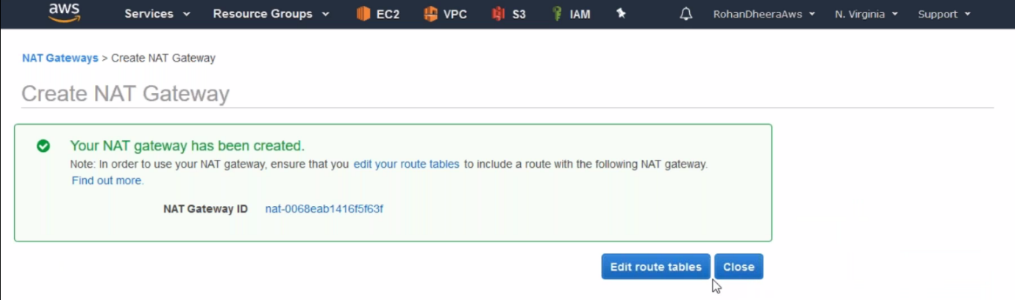

**Route table**

Here we need to connect to the nat gateway.

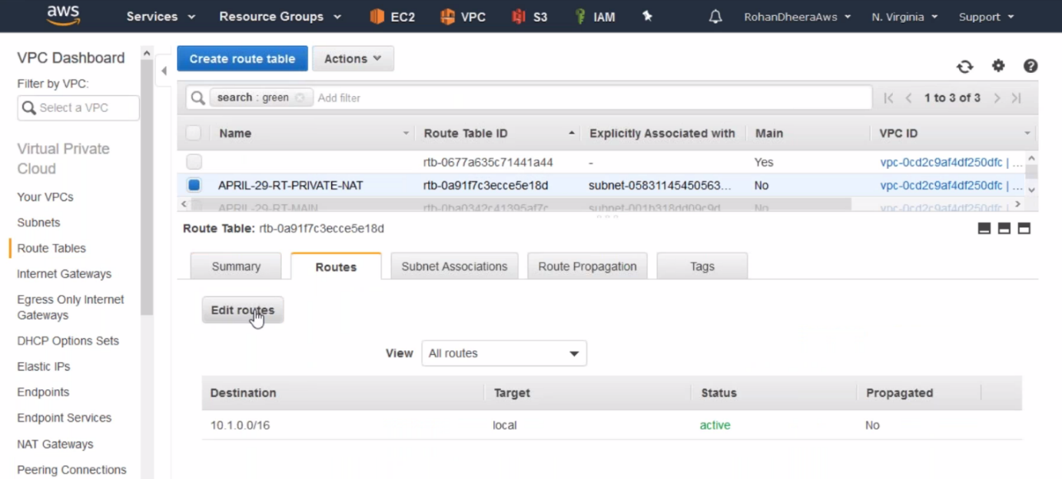

**---** select the private route table and edit it.

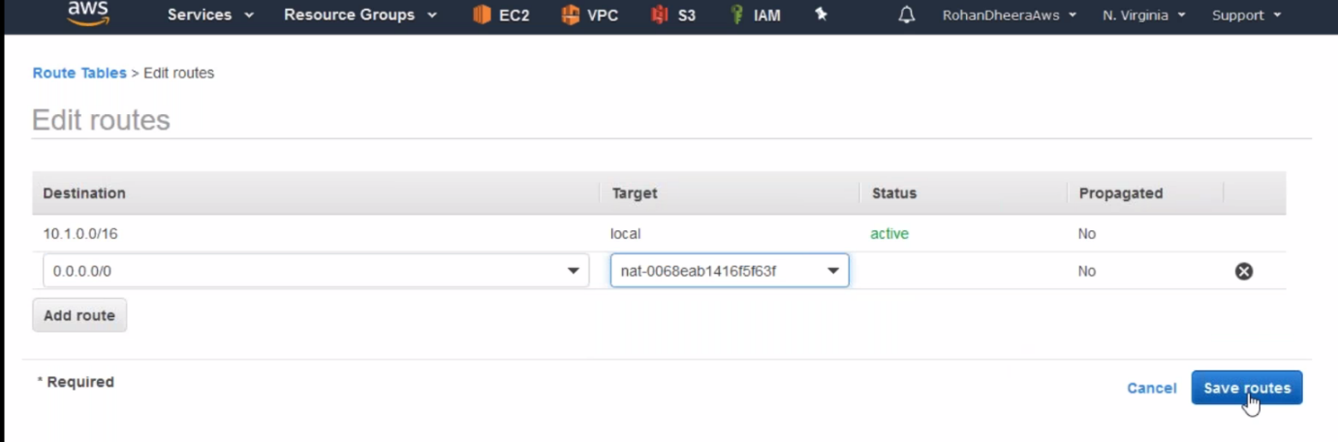

**Connecting the private subnet**

2ways to connect private subnet 1.public subnet 2.from VPN

we cannot connect the private instances using public IP or DNS host name. 1st we need to login in to public subnet and from there we will connect using **ssh ec2-user@10.1.2.100** or we use vpn

**1.connecting private subnet from public subnet**

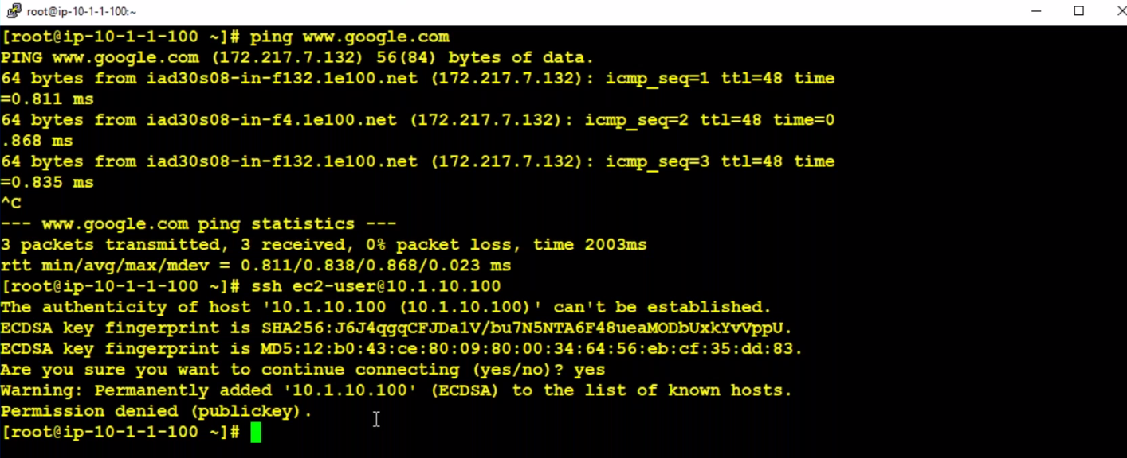

--- here when I try to connect to private subnet from public instance it is asking for pem fiel.

--- we can copy the pem file using WINSCP, but instead of using WINSCP tool I create a file ,name it as a laptop.pem and copy the pem file in there.

--- **nano laptop.pem** – copy the pem file.

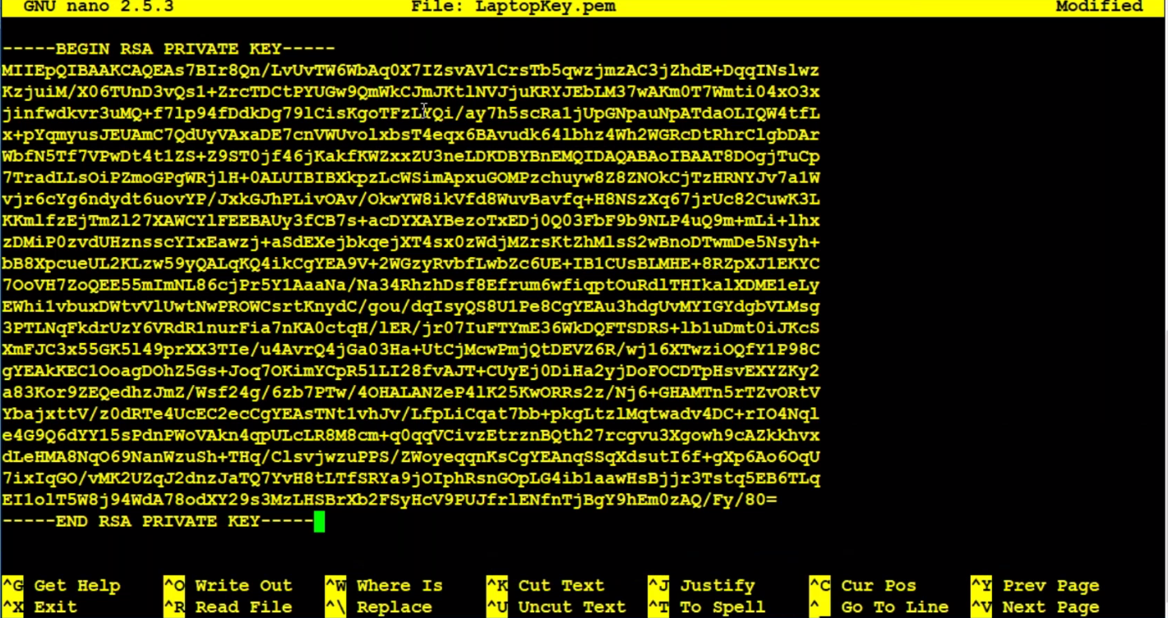

--- **ssh -i laptop.pem** [**ec2-user@10.1.2.100**](mailto:ec2-user@10.1.2.100) – permission will be denied. We have to change permission.

--- **chmod 400 laptop.pem** – now we only giving read permission to root user only.

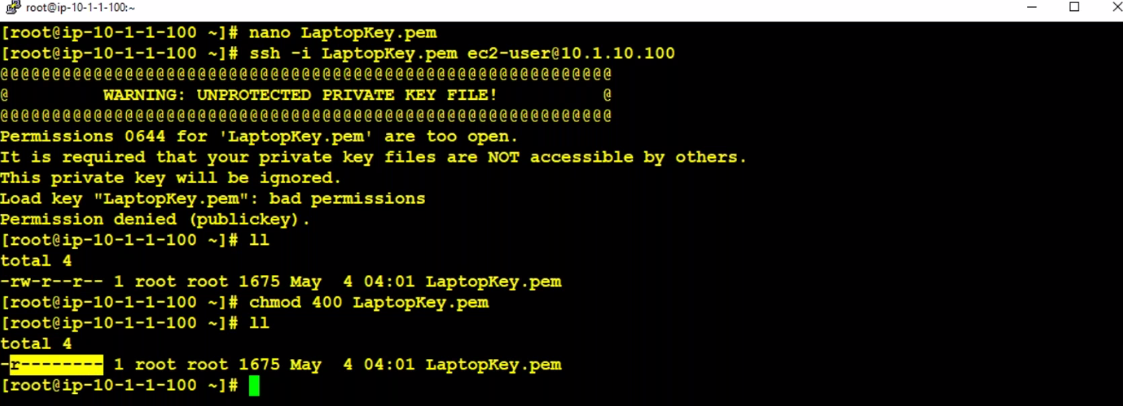

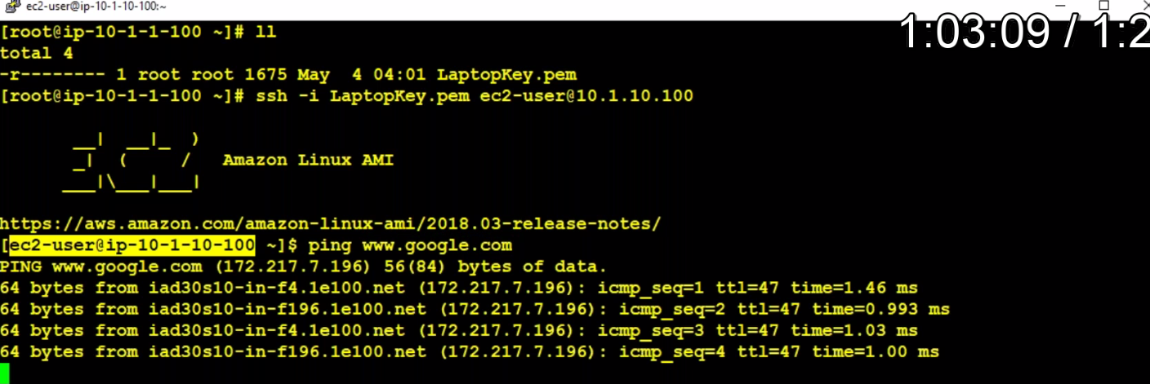

**Elastic IP**

an instance is stopped and restarted, the public IP of the instance will be lost and the new elastic ip would be assigned this elastic IP is permeant. We delete this elastic IP by simply going to the elastic IP which located under networks and securities. If you don’t want to change your public IP address when the instance stopped or rebooted. Then create Elastic IP address and assign that IP address to the instance

--- By default, we can create 5 elastic IP’s

--- elastic IP‘s are used for load balancers in maximum times.

**Elastic IP Creating and assigning to instance**

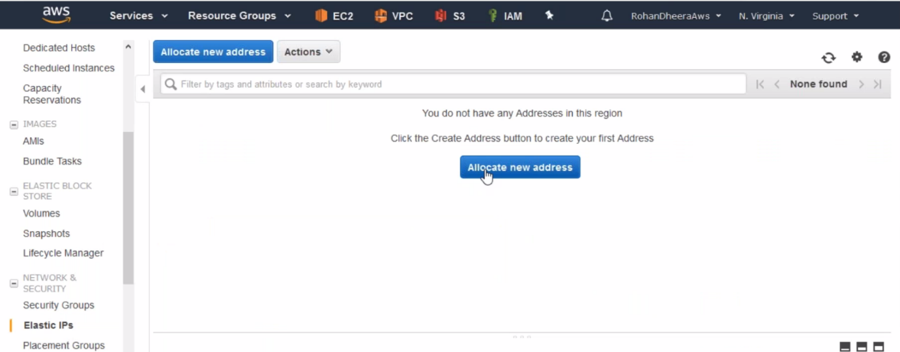

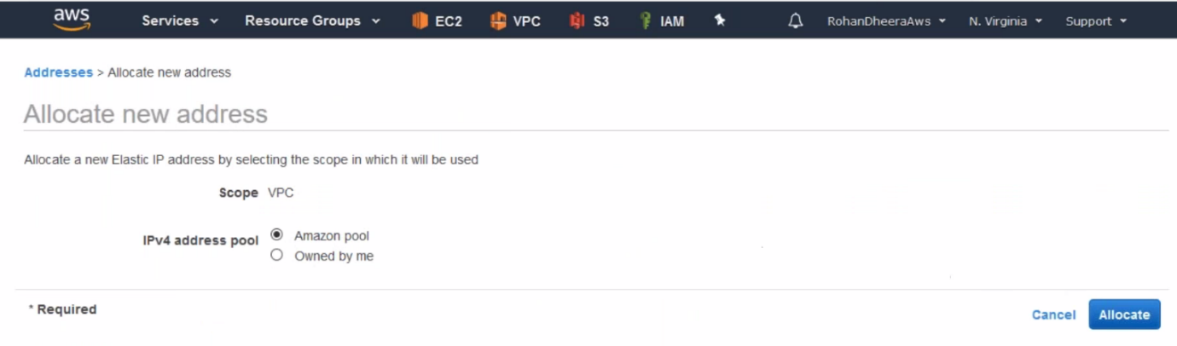

**Assigning to instance**

